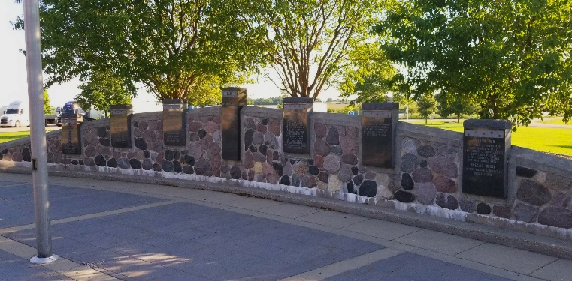
Wisconsin Medal of Honor Wall
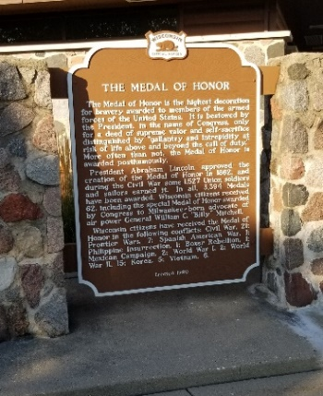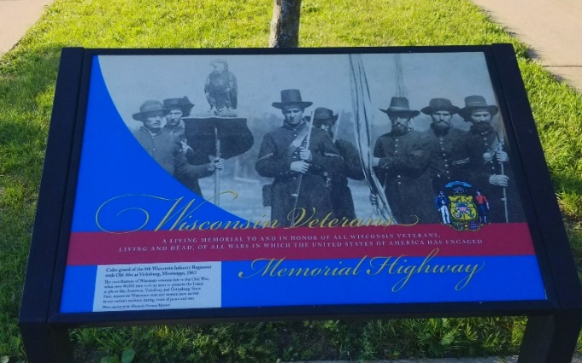
Medal of Honor Plaque Highway Designation
The Blue Star Program honors citizens who serve in the U.S. Armed Forces. National Garden Clubs, Inc. manages the Blue Star Highway System, which covers thousands of miles across the entire United States, with Blue Star Memorial Highway Markers placed along the way. The Blue Star was adopted because it had become an icon in WWII representing each citizen serving in the U.S. Armed Forces. There are currently 14 Blue Star Markers in Wisconsin and 1 more pending.
Gold Star Families is a non-profit organization created to provide support to families who have lost loved ones while serving in the U.S. Armed Forces. NGC has partnered with Gold Star Families and adopted the Gold Star Families Memorial Marker Program. There are currently 2 Gold Star Markers in Wisconsin and 3 more pending.

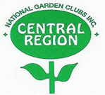
WISCONSIN GARDEN CLUB FEDERATION
PRESIDENT’S PROJECT
2023-25
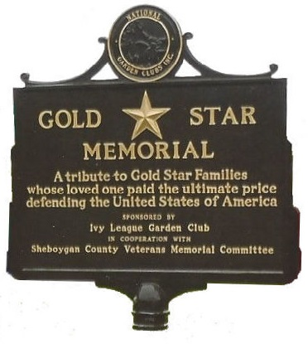
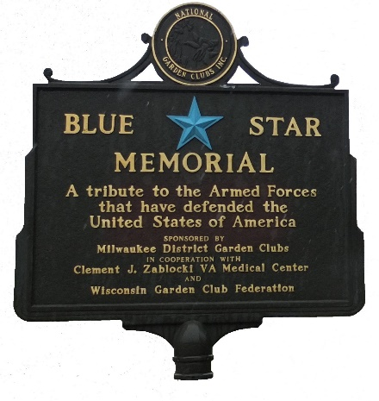
I 90 Rest Stop 22
Beloit, Wisconsin

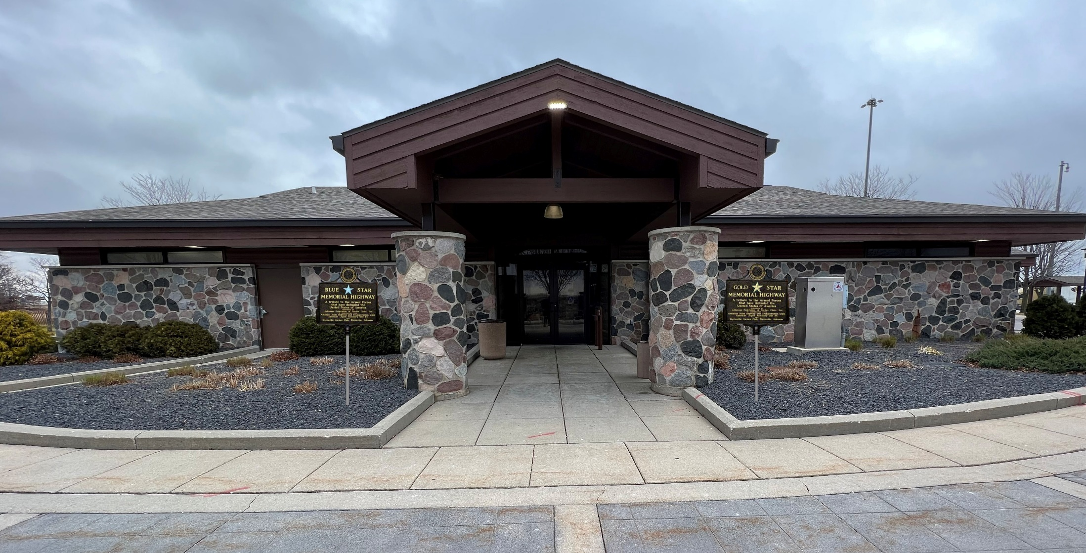

The 23-24 WGCF President’s Project for Linda McCafferty is the installation of Gold and Blue Star Memorial Markers at Rock County Welcome Center 22. The Center is located on I-39 Northbound/I-90 Westbound entering Wisconsin from Illinois and near Beloit. The highway is also known as “Wisconsin Veterans Memorial Highway” and was designated Blue Star Highway in 1987. Approximately 900,000 Wisconsin citizens have served in the US Armed Services and its conflicts.

In addition to a Memorial honoring Wisconsin armed forces members who received the Medal of Honor, the site contains other Memorials dedicated to Wisconsin Veterans who fought in ALL WARS. The placement of a Blue Star Memorial Marker will certainly complement the other monuments already erected on the site.

The addition of a Gold Star Families Memorial Marker will acknowledge the families of the approximately 26,780 Wisconsinites who have paid the ultimate sacrifice in the service of our Nation.

The site also contains a large prairie supporting Wisconsin’s Pollinator Initiative. The garden contains markers explaining what comprises a prairie and identifies some of the native species typically seen on a prairie.

Contributions to this very important Project should be mailed to Joe Powelka at 5361 Betlach Road, Sun Prairie, WI 53590-9781. Your check should be made payable to Wisconsin Garden Club Federation. Please write President’s Project on the memo line. All contributions are tax deductible in accordance with the 501(c)(3) IRC status of WGCF.

